Batch: D - 1 Roll No.: 16010122096

Experiment No. 5

Grade: AA / AB / BB / BC / CC / CD /DD

Signature of the Staff In-charge with date

Title: To develop UML diagrams for selected project
______________________________________________________________________
Aim: To learn and understand the way of creating various UML diagrams for requirement analysis
______________________________________________________________________
CO: Analyse the software requirements and Model the defined problem with the help of UML diagram
______________________________________________________________________

Books/ Journals/ Websites referred:
- Roger Pressman, “Software Engineering”, sixth edition, Tata McGraw Hill.
- System Analysis & Design by Satzinger, Jackson and Burd, Cengage Learning, 2007
- System Analysis and Design Methods by Jeffery l. Whitten, Lonnie D Bentley,McGraw Hill, 7th edition.
- System Analysis and Design by Alan Dennis, Barbara H. Wixom, Roberta M. Roth,Wiley India 4th edition
- http://en.wikipedia.org/wiki/Software_requirements_specification
- http://en.wikipedia.org/wiki/Use_case

__________________________________________________________________

Pre Lab/ Prior Concepts:
Use Case Diagram:
- A use case diagram shows the interaction between users (actors) and the system. It highlights the different functionalities (use cases) the system provides and who interacts with them.
- In your project, the use case diagram helps identify the key features of the system and the primary actors involved. It provides a high-level view of what the system will do, allowing stakeholders to understand the system's capabilities and how users will interact with it.
Activity Diagram:
- An activity diagram represents the workflow or the sequence of activities in a system. It illustrates the dynamic aspects of the system, showing how different activities are connected and the flow of control from one activity to another.
- For your project, the activity diagram helps map out the processes or workflows within the system. It allows you to visualize how the system behaves during different operations, such as how a user might navigate through the system or how different components interact during a process.
Sequence Diagram:
- A sequence diagram focuses on the time-ordering of messages or interactions between objects or components in the system. It shows how objects interact with each other over time to carry out a particular functionality.
- In your project, the sequence diagram is used to detail the interactions between objects for specific use cases. It helps in understanding the flow of messages between objects, the order of operations, and how the system's components work together to achieve a particular outcome.
Class Diagram:
- A class diagram describes the static structure of the system by showing the system's classes, their attributes, operations, and the relationships between them.
- For your project, the class diagram serves as the blueprint for the system's code. It defines the system's data structure and the relationships between different entities (classes). This diagram is essential for understanding how the system's data is organized and how different classes interact to perform the system's functionalities.
Developing these UML diagrams for your project provides a comprehensive view of both the static and dynamic aspects of the system. They are crucial for the design phase, ensuring that all stakeholders have a clear understanding of the system's architecture and behavior. By creating these diagrams, you lay the foundation for a well-structured, maintainable, and scalable software system.

Diagram for your system:
Use case:

Activity diagram:
Sequence diagram:
Class diagram:

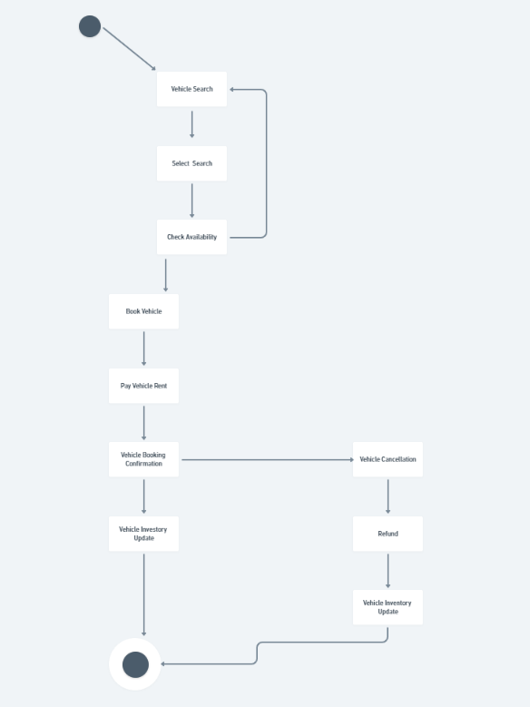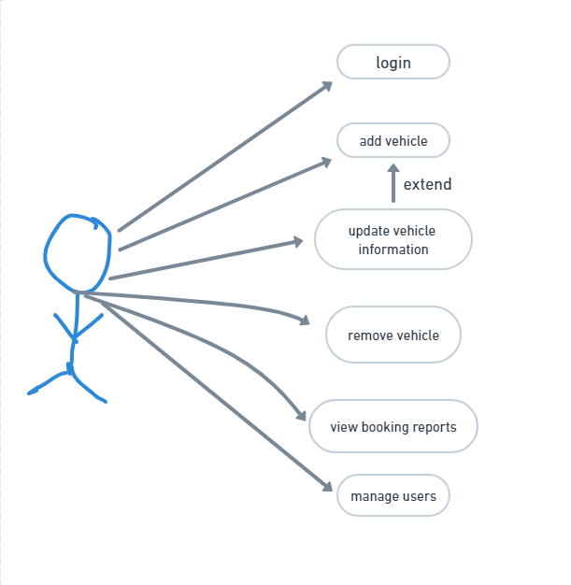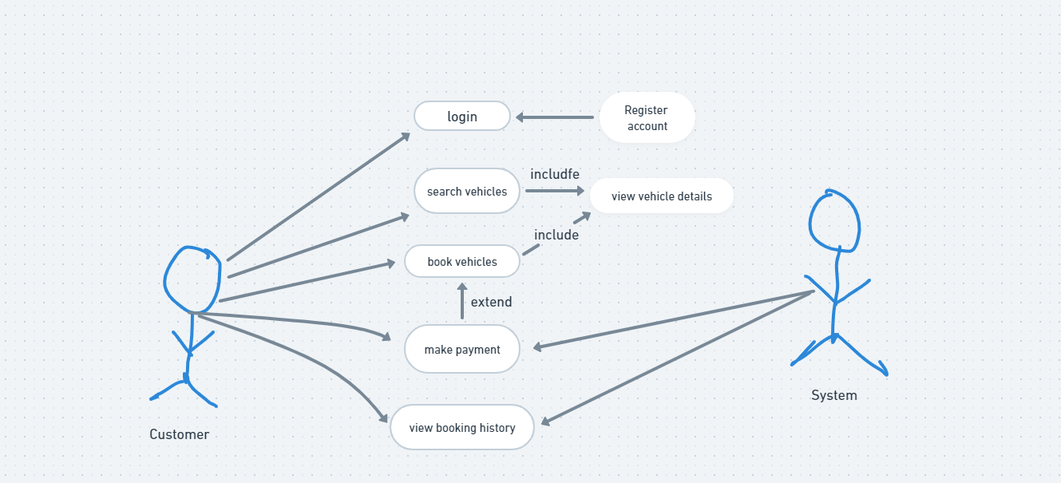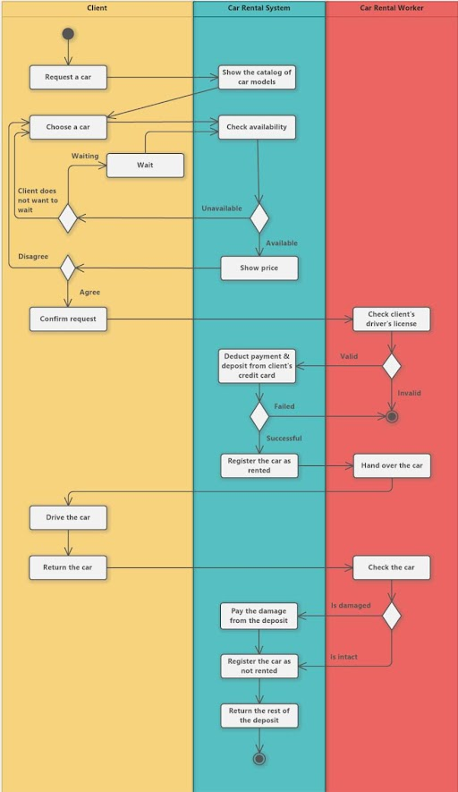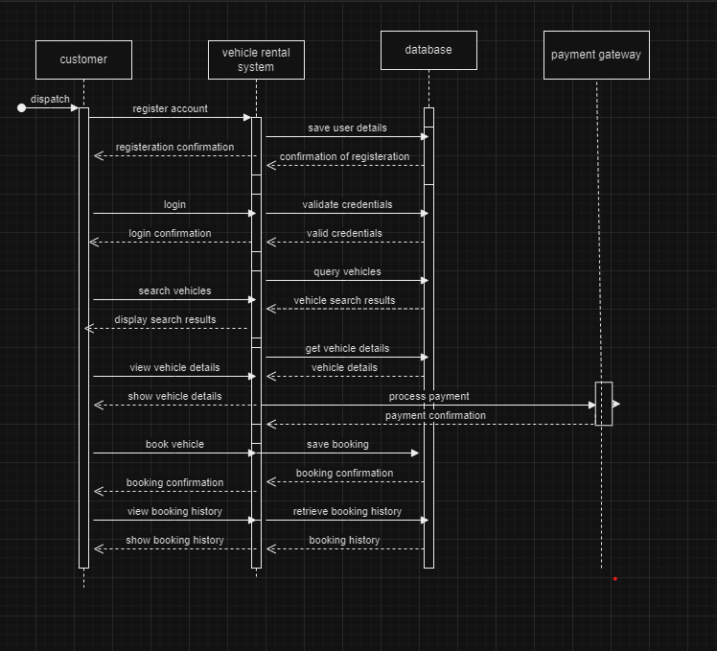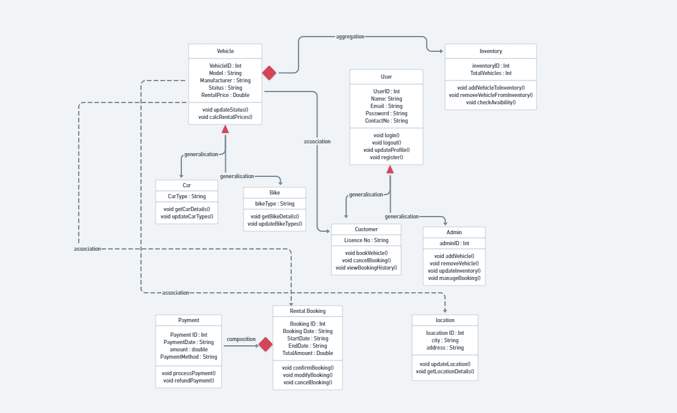
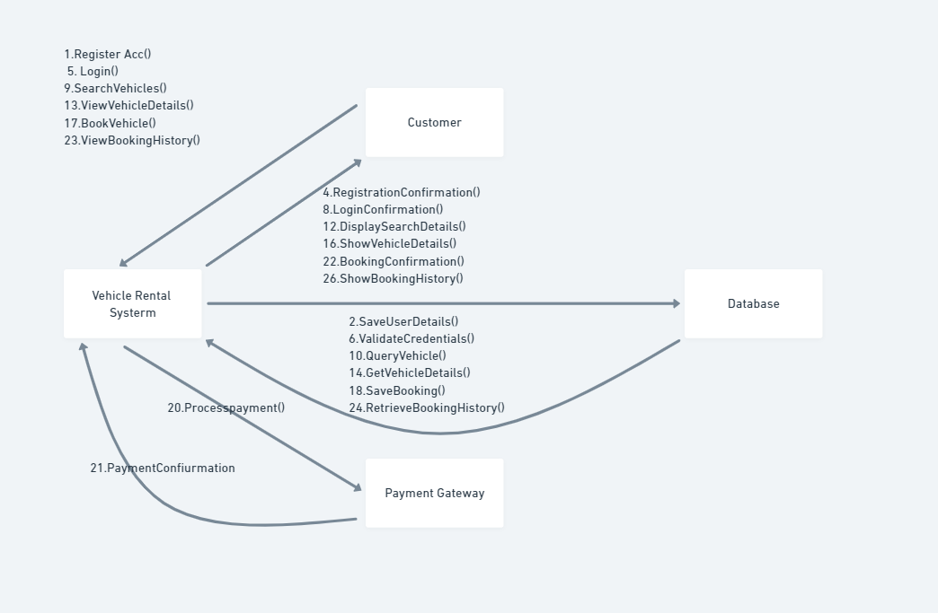
Conclusion:

Post Lab Descriptive Questions:

- Where do use cases fit in the software development life cycle?
Use cases fit into the software development life cycle (SDLC) in several key phases:
  - Requirements Gathering: They help capture user needs and expectations.
  - Analysis and Design: Use cases guide system design by outlining user interactions.
  - Development: They serve as a reference for developers during coding.
  - Testing: Test cases are derived from use cases to validate system behavior.
  - Documentation and Training: Use cases can aid in creating user manuals and training materials.
  - Maintenance: They help assess the impact of updates on existing functionality.
Overall, use cases ensure a user-centered focus throughout the SDLC.
- Compare sequence diagram with collaboration diagram. Explain pros and cons of each.
Sequence Diagram:
- Description: Shows interactions over time, emphasizing the order of messages.
- Pros:
  - Time Focused: Clearly illustrates the sequence of events.
  - Good for Complex Interactions: Easier to understand detailed scenarios.
- Cons:
  - Less on Relationships: Doesn’t highlight object relationships as clearly.
  - Can Be Crowded: May become cluttered with complexity.

Collaboration Diagram:
- Description: Focuses on object relationships and message exchanges in a network layout.
- Pros:
  - Emphasizes Relationships: Clearly shows how objects are connected.
  - Compact Representation: More concise for simpler interactions.
- Cons:
  - Less Clarity on Timing: Doesn’t clearly show the order of messages.
  - Can Be Confusing: May struggle with complexity in interactions.

- List different notations used in Class diagram with example

1. Class Notation
- Symbol: Rectangle divided into three sections (name, attributes, methods).
- Example:
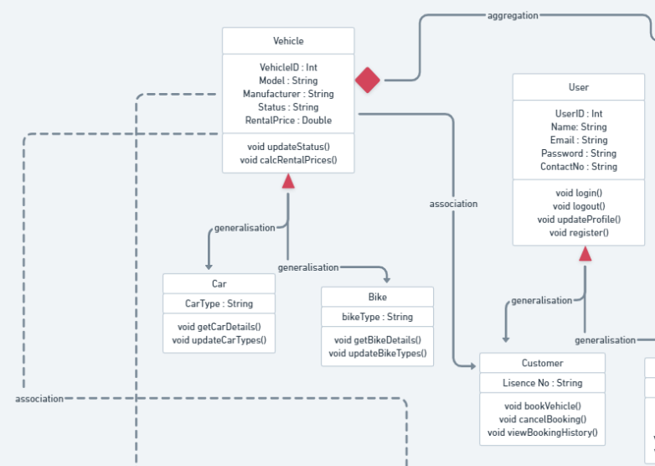

2. Attribute Notation
- Symbol: Attribute name followed by a colon and its type; visibility indicated by a symbol.
- Example:
  - - name: String (private)
  - + age: Int (public)

3. Method Notation
- Symbol: Method name followed by parentheses; visibility indicated by a symbol.
- Example:
  - + getName(): String (public method that returns a String)

4. Visibility Notations
- Symbols:
  - + (public)
  - - (private)
  - # (protected)
- Example:
  - # address: String (protected attribute)

5. Association
- Symbol: Solid line connecting classes, often with arrowheads.
- Example:
  - Person ----> Car (a Person owns a Car)

6. Multiplicity
- Symbol: Numbers or symbols near association lines (e.g., 1, 0..*).
- Example:
  - Person 1 ---- 0..* Car (a Person can own multiple Cars)

7. Inheritance
- Symbol: Solid line with a hollow arrow pointing to the parent class.
- Example:
Employee ----|> Person

8. Dependency
- Symbol: Dashed line with an arrow.
- Example:
Person -----> Address

9. Aggregation
- Symbol: Hollow diamond at the aggregator end.
- Example:
Team <>---- Player

10. Composition
- Symbol: Filled diamond at the whole end.
- Example:
House ◆---- Room

- Virtual Lab Link: http://vlabs.iitkgp.ernet.in/se/7/
- Modeling UML Use Case, Class diagram, Sequence Diagram.
- Virtual Lab Link: http://vlabs.iitkgp.ernet.in/se/3/exercise/
- Virtual Lab Link: http://vlabs.iitkgp.ernet.in/se/5/exercise/
- Virtual Lab Link: http://vlabs.iitkgp.ernet.in/se/6/

1. UML Use Case Diagram
Purpose: Captures functional requirements and interactions between users (actors) and the system.
Components:
- Actors: External entities (users or systems) that interact with the system.
- Use Cases: Functionalities or services provided by the system.
Example:
[User] --> (Login)
[User] --> (View Profile)
[Admin] --> (Manage Users)

2. UML Class Diagram
Purpose: Represents the static structure of the system, including classes, attributes, methods, and relationships.
Components:
- Classes: Defined with attributes and methods.
- Relationships: Associations, inheritance, aggregation, and composition.
Example:

3. UML Sequence Diagram
Purpose: Describes how objects interact in a specific sequence of events, highlighting the order of messages.
Components:
- Lifelines: Represent objects or actors.
- Messages: Arrows that show the communication between lifelines.
Example:

